spectacular (adj).

Pronunciation: spec TA cu lar

Meaning: very impressive or exciting.

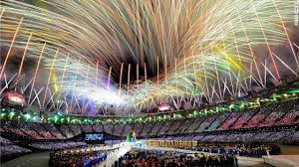 Closing ceremony of the London Olympics 2012

A sentence from my life:
My kids loved the spectacular closing ceremony of the London Olympics.

